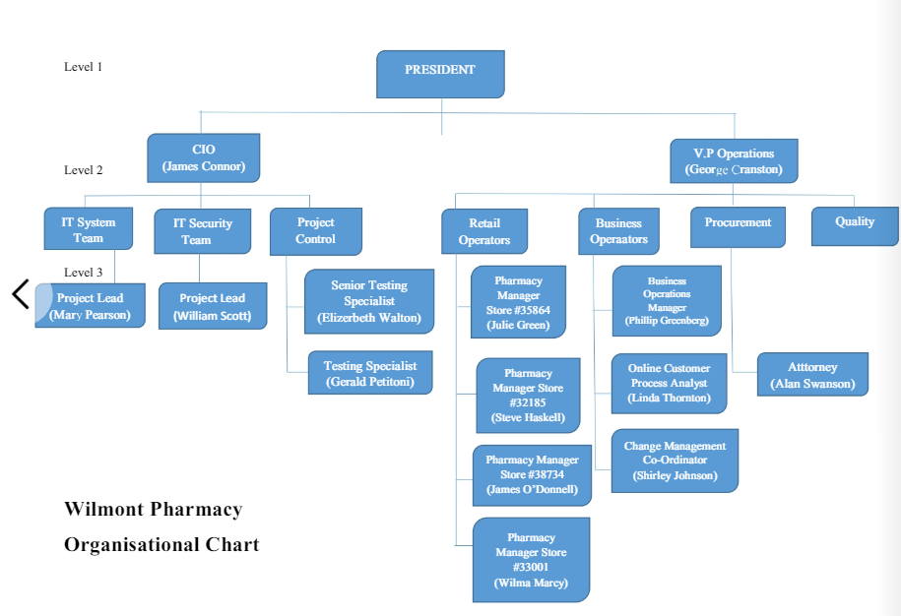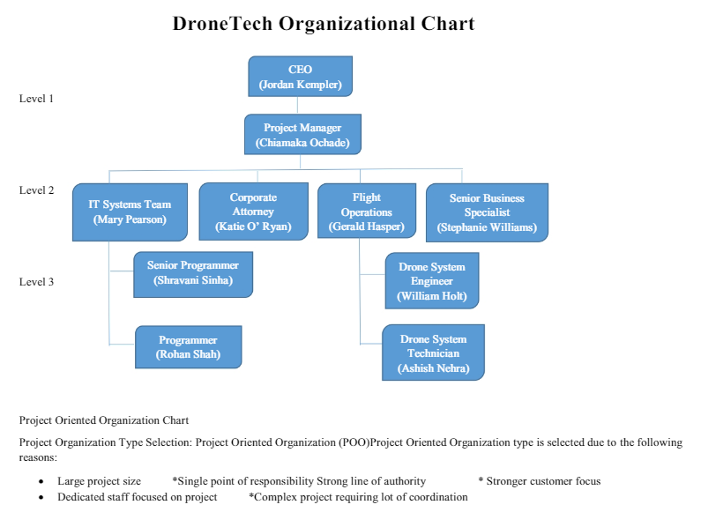

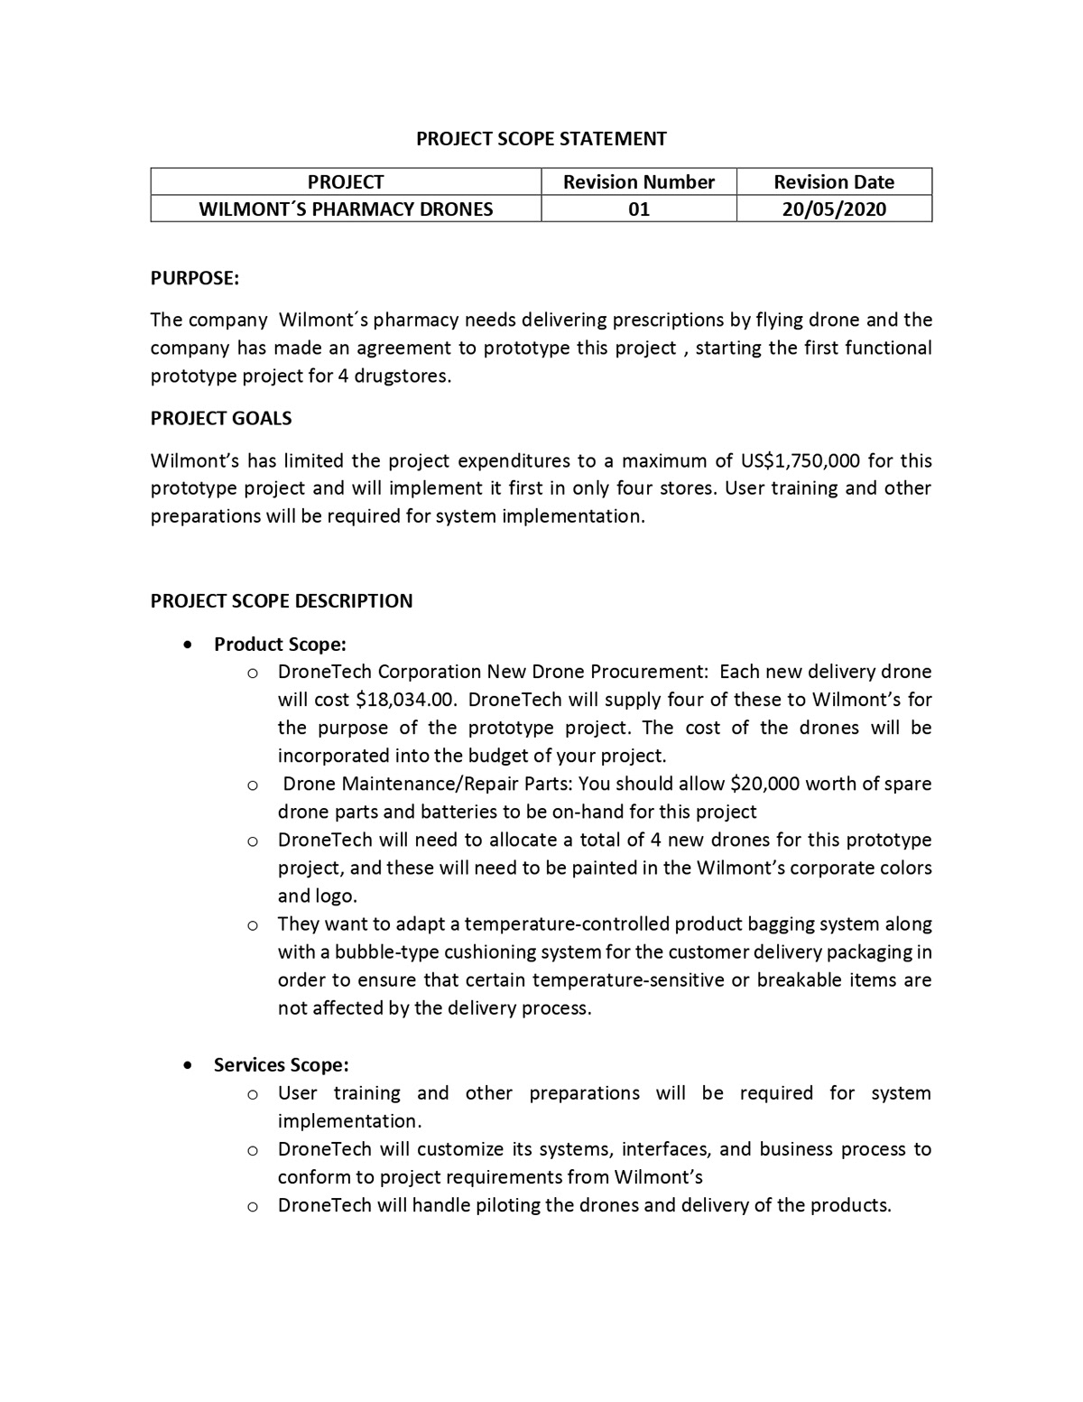

|  |  |  |  |
| --- | --- | --- | --- |
| **Project Name** | Drone Project | | |
| **Project Phase** |  | | |
| **Name of Stakeholder** | **Designation** | **Department** | **Role in Project** |
| jujuu | primary | CEO | Leader, drone tech |
| moh | primary | operation |  |
| khaled | primary | Project lead | drone tech |
| momo | primary | It System | Qaulity Assurance |
| rami | primary | It System | Qaulity Assurance |
| mohamed | primary | Cio |  |
| ahmad | primary | BUSSINESS OPERATION | drone tech |
| ramis | primary | IT security | drone tech |
| islam | Secondary | Legal | drone tech |
| zian | Secondary |  | drone tech |
| liyana | Secondary |  | drone tech |
| kali | tertiary | Drone system | drone tech |
| mjd | tertiary | pharmasy | drone tech |
|  |  |  |  |

Stakeholder Registry

|  |  |  |  |
| --- | --- | --- | --- |
| **Date 1/23/21** | | | |
| **1Type of Stakeholder** | **Type of Communication** | **Interests** | **Influence on Project**  **Outcome** |
| **internal** | **In person** | **leading** | **high** |
| **internal** | **In person** | **support** | **high** |
| **internal** | **In person** | **neutral** | **high** |
| **internal** | **In person / email** | **leading** | **high** |
| **internal** | **In person /email** | **leading** | **high** |
| **internal** | **Phone / email** | **leading** | **low** |
| **external** | **Phone / email** | **supportive** | **high** |
| **external** | **Phone / email** | **supportive** | **low** |
|  |  |  |  |

Project Charter

Wilmont’s Pharmacy Drone Project

January 22th 2021

|  |  |  |
| --- | --- | --- |
| Project Description | Wilmont’s Pharmacy made an agreement with DroneTech to prototype a flying drone for home delivery of prescriptions. DroneTech will provide the drone technology as well as the drone piloting and delivery systems | |
| Project Purpose | The purpose of the project is to develop a prototype of flying done delivering prescriptions and drugstore items in the San Francisco area | |
| Scope/boundaries | The Operations Vice President (George Cranston) of Wilmont’s will provide the funds and will oversee all aspects of this initiative. DroneTech organization will develop the prototype and will customize its systems, interfaces, and business process to conform to project requirements from Wilmont’s . DroneTech will handle piloting the drones and delivery of the products. The drones maintenance will be done by DroneTech .The project will be deployed first in san francisco area in only four stores. | |
| Requirements | The drone should be developed and customized its systems, interfaces, and business process to conform to project requirements from Wilmont’s. The project will likely need to accomplish the following in order to appear seamless to Wilmont’s pharmacy customers: -DroneTech will handle piloting the drones and delivery of the products. - Interface to Wilmont’s enhanced online order entry process that will allow customers in the San Francisco area to register their willingness to have a drone deliver their orders by means of online entry or smartphone entry - Interface communications about deliveries for Wilmont’s customers electronically through email, online, and through mobile alerts as the customer requests - Interface communications about deliveries for Wilmont’s customers electronically through email, online, and through mobile alerts as the customer requests. | |
| Deliverables/Objective | Deliverables/Objective | Success Criteria |
| Drone piloting and delivery systems | the project expenditures to a maximum of US$1,750,000 for this prototype project and will implement it first in only four store |
| Customized interface | A customized its systems, interfaces, and business process to conform to project requirements from Wilmont’s must be developed. |
| Secure and quality System | Risks, testing, quality control and provision issues may develop |
|  |  |
| Schedule | The project begins next January 5 and the first customer delivery flight should take place no later than November 30 to avoid harsh weather in the San Francisco area | |
| Budget | maximum of US$1,750,000 | |
| Assumptions and constraints | Total Project Cost must not exceed Project Constraints. Project schedule should begin January 5, and should meet the schedule constraints as per the case for completion | |
| Risks | risk management will be carried out | |
| References | The project concept isn’t new for DroneTech and DroneTech will be based on an already existing drone system. | |

\\\\

